Subject : DSE(Computer Applications) Cyber Forensics

Practical 4

- Capture and analyse network packets using Wireshark. Analyse the packets captured.

- Wireshark is a powerful, open-source network protocol analyser used to capture and inspect packets at a very detailed level. It helps in:
- Troubleshooting network issues
- Monitoring traffic flow
- Analysing protocols
- Identifying suspicious or malicious communication
- Learning how networking works at the packet level
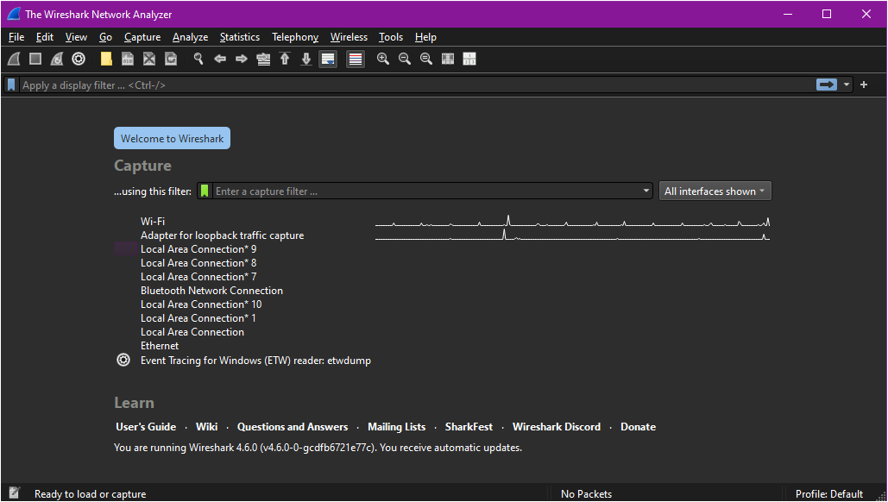
Figure 1. Wireshark home screen showing network interfaces

- Wireshark displays packets in real time and provides deep decoding of protocols such as Ethernet, IP, TCP, UDP, ICMP, HTTP, DNS, and many more.

- Steps to Capture Packets

- Start Wireshark : Open Wireshark. It will display all available network interfaces (like Wi-Fi or Ethernet).
- Select an Interface : Choose the network interface you want to capture traffic from (e.g., Wi-Fi). [Figure 1]
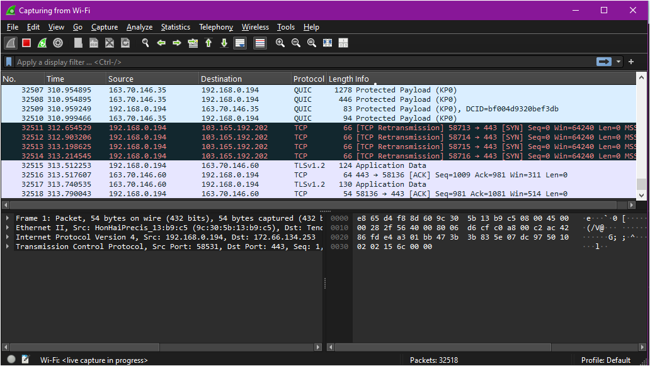
- Click Start Capturing Packets.

Figure 2. Live Packet Capture in Progress
- Generate Network Traffic :To capture meaningful traffic, open a few websites or run applications that use the internet. Examples:
- Open Google.com
- Ping a website
- Stream a video
Packets will start appearing in Wireshark.[Figure 2]

Stop the Capture : After collecting enough packets, click the Red Square (Stop Capture) button.

Packet Analysis : Wireshark displays packets in three main panes:

- Packet List Pane : | Shows each captured packet with:  - Packet number  - Timestamp  - Source & Destination IP  - Protocol (TCP, UDP, DNS, HTTP, etc.)  - Brief info | 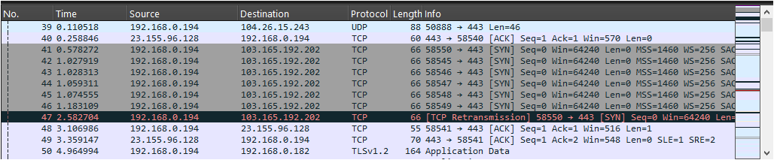
- Packet Detail Pane : | Shows detailed breakdown of layers:  - Ethernet Frame  - IP Header  - TCP/UDP Header  - Application Layer Protocol (DNS, HTTP, etc.) | 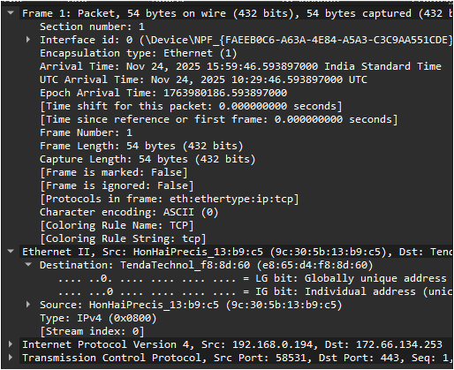
- Packet Bytes Pane : | Displays raw packet data in hexadecimal and ASCII format. | 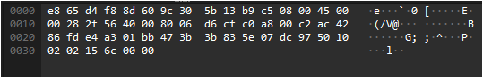

- Analysis of Packets :

- ARP Packet | • Used for mapping IP address to MAC address.  • Shows "Who has X.X.X.X? Tell Y.Y.Y.Y" | 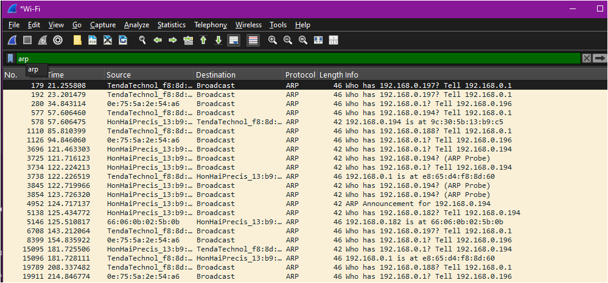
- DNS Packet | - Used to query domain names.  - Example: Query for "www.google.com"  - Key fields:  - Transaction ID  - Query Type (A record)  - Flags (standard query) | 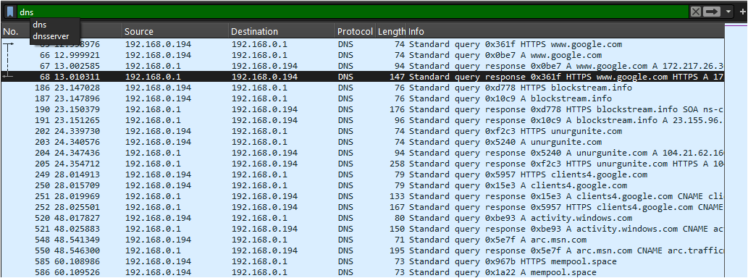
- TCP Packet | Observations:  - Source & destination ports  - Sequence and acknowledgment numbers  - Flags (SYN, ACK, FIN, etc.)  Example:  - SYN → Connection start  - SYN-ACK → Response  - ACK → Handshake completion | 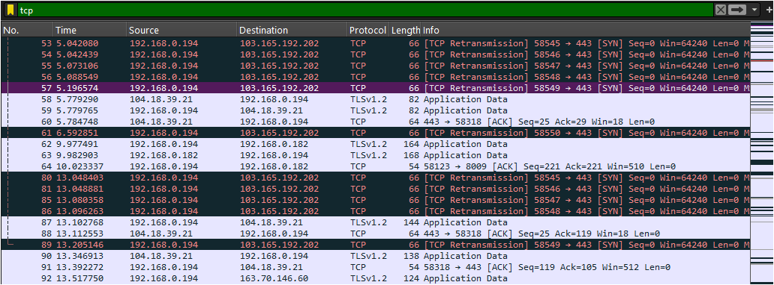
- HTTP Packet | Shows communication between browser and server.  Example:  - HTTP GET request  - Hostname  - User-Agent  - Response code (200 OK) | 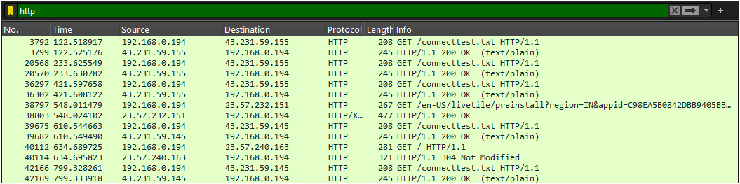
- ICMP Packet | Used for Ping.  Types:  - Echo Request  - Echo Reply | 